Grade 7 Accelerated · Unit 3 · Lesson 1  Product Laws of Exponents  Question Bank - Additional 3.01 ANSWER KEY | Name  Date  Period

Show your work. Circle your final answer.
For questions 1 and 2, write the product as a repeated multiplication expression, then as a single power.
1. 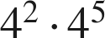


2. 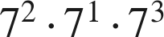

2 + 1 + 3 = 6.

3. Evaluate each power, then multiply. 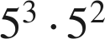
125 · 25 = 3,125
Also 5⁵.

4. Apply the product of powers law, then evaluate the power. 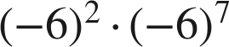

Nine negative factors: negative.

5. Leeland says he can evaluate 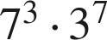 using the product of powers law. Is he correct? Explain.
No — the bases are different (7 and 3), so the law does not apply. The value is 343 · 2,187 = 750,141, found by evaluating each power.

For questions 6 through 8, use the power of a product law.
6. Write 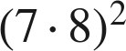 as a repeated multiplication expression, group the repeated factors, then write it in the form 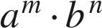.
Value 3,136 either way.

7. Evaluate inside the parentheses first, then apply the exponent. 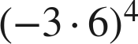

Math Nation's key prints 104,796 for this item; it is 104,976.

8. Apply the power of a product law, then evaluate. 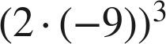

For questions 9 and 10, use the power of a power law or the identity law.
9. Write 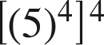 as a single power, then give its value.


10. Rewrite 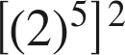 using a law of exponents, name the law, then evaluate.
 — power of a power
Math Nation's key stops at 2¹⁰; the question asks for the value.

Working backwards.
11. Find the value of that makes each statement true.
a. 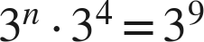
n = 5
b. 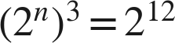
n = 4
c. 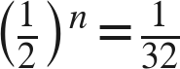
n = 5

12. Which expression is equivalent to 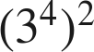 ?
○ A. 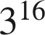
● B. 
○ C. 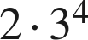
○ D. 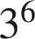
B
Multiply the exponents.

13. Select ALL of the expressions that are equivalent to .
☐ A. 
☐ B. 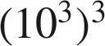
☒ C. 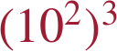
☒ D. 
☒ E. 
☒ F. 
C, D, E and F
F: 100³ = 1,000,000 = 10⁶.

